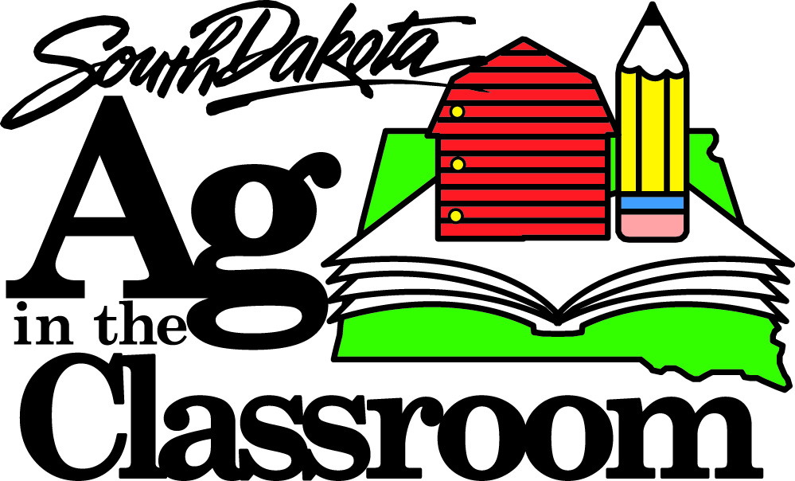
2014 “The Surprising Places I Found Agriculture” Essay Contest
Sponsored by South Dakota Ag in the Classroom
and South Dakota Farm Families

Rules:
- Open to any 3rd and 4th grade classroom in the state of South Dakota.

- Students should use the topic “The Surprising Places I Found Agriculture” as the inspiration for their essays. The focus should be on non-food uses for agricultural products.

- Essays should be a minimum of 100 words, maximum of 250 words in length.

- Essays must be typed. Please include your name and school on the top of the essay.

- Essays are due March 28, 2014, and should be sent to:

Ag Week Essay Contest
c/o South Dakota Ag in the Classroom
PO Box 402
Miller, SD 57362

Or e-mailed to
sdagclassroom@yahoo.com with “Ag Week Essay Contest” in the subject line

- Winners will be announced on the South Dakota Ag in the Classroom and South Dakota Farm Families Facebook pages by April 15, 2014. The teacher of the winning student will be notified via e-mail as well.

- The winner will receive a classroom pizza party on a date to be determined by the teacher and South Dakota Farm Families staff.
  - South Dakota Farm Families will furnish the supplies for the party and bring along an agricultural producer to discuss what part of the pizza he/she produces.
  - Parents of the winning student will be invited to join the party as well.
  - Student will be invited to read his/her winning essay in front of class and receive a certificate of congratulations.
  - The winning essay will be published on the South Dakota Ag in the Classroom and South Dakota Farm Families websites and Facebook pages (using only the student’s first name and school as identifying information).
  - The teacher of the winning student will receive a prize pack as well, containing lessons, activities and information from South Dakota Ag in the Classroom and South Dakota Farm Families.

- This essay contest can be used to help students meet the following South Dakota Department of Education standards: 3.W.1; 3.W.4; 3.W.5; 3.W.6; 3.W.7; 3.L.1b-f; 3.L.2; 3.L.3b; 4.W.1; 4.W.4; 4.W.5; 4.W.6; 4.W.7; 4.L.1b-g; 4.L.2; 4.L.3a,b
2013 “How Agriculture Impacts Me Every Day” Essay Contest
Sponsored by South Dakota Ag in the Classroom
and South Dakota Farm Families
(Please type or print.)

Student Name:
School Name:
School Address:

Teacher’s Name:
Teacher’s E-mail Address:
How did your teacher/parent find out about this contest?

Please have your parents read the following and sign below:
The undersigned (on my behalf and, if applicable, on behalf of my child/children), hereby authorizes South Dakota Ag in the Classroom and South Dakota Farm Families and their affiliates to use, publish, circulate and reprint photographs, digital or printed materials, images or other forms of data identifying, showing or depicting me or created by me (or, if applicable, my child/children) in any publication, website, Facebook, other Internet site, press release, any other media, and all derivative works and other uses.

Name of Student: ______
(print name(s))

Dated:
Signature of Parent (if student is under age 18)
Name:
(print name)

