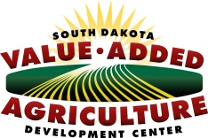
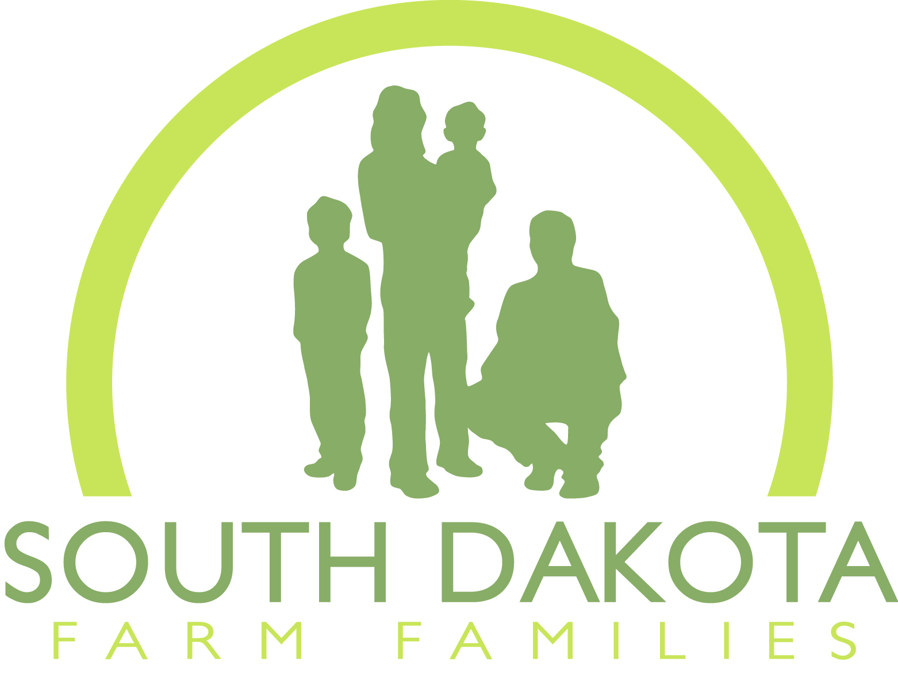
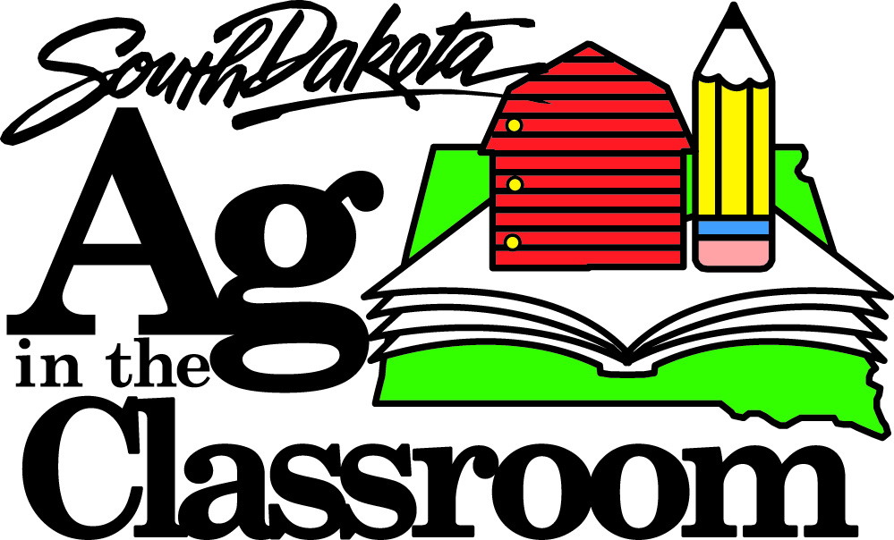

2016 “If I Could Develop One New South Dakota Ag Product, It Would Be…”
Essay Contest Sponsored by South Dakota Ag in the Classroom, South Dakota Farm Families and South Dakota Value Added Ag Development Center

Rules:
- Open to any high school senior in the state of South Dakota.

- Students should use the topic “If I could develop one new South Dakota ag product, it would be…” as the inspiration for their essays. The focus should be on new and original ideas for producing and processing novel products utilizing commodities grown in South Dakota.

- Essays should be a minimum of 500 words, maximum of 1,000 words in length. Sources of information must be listed and referenced in APA style. A bibliography must be included. Failure to include bibliography and references for work will result in disqualification.

- Essays must be typed. Please include your name and school in the header of the essay. A completed entry form must accompany the essay.

- Essays are due March 11, 2016, and should be sent to:

Ag Week Essay Contest
c/o South Dakota Ag in the Classroom
PO Box 402
Miller, SD 57362

Or e-mailed to
sdagclassroom@yahoo.com with “Ag Week Essay Contest” in the subject line

- One winner will be chosen. Winners will be announced on the South Dakota Ag in the Classroom and South Dakota Farm Families Facebook pages beginning March 14, 2016. The teacher of the winning student will be notified via e-mail as well.

- The winner will receive $250 cash, provided by South Dakota Farm Families.
  - The winning essay will be published on the South Dakota Ag in the Classroom and South Dakota Farm Families websites and Facebook pages (using only the student’s first name and school as identifying information).
  - Check will be presented at a date and time to be mutually determined by South Dakota Farm Families staff or affiliates and the student.

2016 “If I Could Develop One New South Dakota Ag Product, It Would Be…”
Essay Contest Sponsored by South Dakota Ag in the Classroom, South Dakota Farm Families and South Dakota Value Added Ag Development Center
(Please type or print.)

Student Name: Gender:
School Name: Grade:
School Address:

Homeroom or FFA Teacher’s Name:
Teacher’s E-mail Address:
How did your teacher/parent find out about this contest?

Please have your parents read the following and sign below:
The undersigned (on my behalf and, if applicable, on behalf of my child/children), hereby authorizes South Dakota Ag in the Classroom and South Dakota Farm Families and their affiliates to use, publish, circulate and reprint photographs, digital or printed materials, images or other forms of data identifying, showing or depicting me or created by me (or, if applicable, my child/children) in any publication, website, Facebook, other Internet site, press release, any other media, and all derivative works and other uses.

Name of Student: ______
(print student’s name)

Dated:
Signature of Parent (if student is under age 18)
Name:
(print parent’s name)

